- 2nd Iteration: Developing Game Play: Decomposition of Functions Layout and Requirements
Analysis
  - Before developing the detail of the game, I further decomposed the Play Game block of this project to a sub-structure diagram as follows:
Why? decomposing the Play Game function will give me an idea of the sub programs I will need to create a working solution.

  - Overall Requirements: Before creating the game play, I reviewed my overall requirements, which I previously outlined as initial ideas. My refined overall requirements are:
  - Only users can play games (Admin must also have a user account to check games).
Why? Having Admins actually play the games might disrupt the leaderboards for the normal users.
  - The User should have the option to:
  - Select a Maze with a difficulty Level (Easy, Medium, Hard) – I will be using a single development maze to create the format and workings of my game, so this is a future development opportunity.
Why? I would like to motivate my users to start at an appropriate difficulty so that they do not get put off by questions that are either too easy or too difficult. Not putting people off was a key stakeholder requirement.
  - Clueset Selection Admin must assign a mandatory Clue set to each maze (as seen in my database maze definition), so clueset selection cannot be done additionally by the User.
Why? My teacher stakeholder wanted a game that he could use with classes and he requested the ability to assign different clue sets to different classes, rather than have the user choose it themselves.
  - Hero is the User’s selected Avatar: The maze game should play with the chosen avatar for the hero.
Why? It is important to engage the Users and my stakeholders were positive about having the ability to choose an avatar because it will make the game feel more personal and therefore more attractive to play.
  - Future Development Idea: The user could choose whether to have a timer shown and be added to the leaderboard.

  - Detailed Requirements: The information above is a decomposition of the problem and to summarise this, to solve a maze, the User will have already selected the maze from a list of options, depending on difficulty. The maze definition will have a clue set and MaxTime assigned by Admin. Having the admin manage the maze setup ensures that the normal user cannot tamper with it and the variables on the game that is set is a fixed for all users to allow for comparison and fair leaderboards.

  - I am now going to consider the different elements of my decomposed system to provide more detail about my thinking. I will cover areas of the coloured boxes on the diagram below in the next section:

  - Main Function: I can imagine a function called:
PlayGame(MazeName, UserName, RecordResult)
This breaks into:
- MazeName is the selected maze, and the database Maze table can be queried for the associated file; The associated Clue Set filename can also be determined.
- UserName(string) so the User can be messaged by name and their Avatar can be queried from the User table.
- RecordResult is a Boolean to flag whether to return the game stats, or not.
- Why? By having these variables passed as parameters to the given function, it ensures the data is not changed elsewhere in the system if it is edited within the function. It also means that the game played is correct.
- The function will return the game stats as follows:
  - Score(integer) – total achieved
  - TimeTaken(string in time data type format hh:mm:ss) – time taken to complete maze
  - NumEasy(integer) – number of easy difficulty clues solved
  - NumMedium(integer) – number of medium difficulty clues solved
  - NumHard(integer) – number of hard difficulty clues solved
- Why? These stats will be used in the leaderboards to display an accurate representation of the last played game.

  - Accuracy can either be computed in the PlayGame function, or outside of it using the returned stats. Either call a function CalcStats in PlayGame or outside – the function is the same:
Function CalcStats(TimeTaken, NumEasy, NumMedium, Num Hard)
- Why? By calculating accuracy, the admin or teacher can still see that the user might have a high accuracy and is doing well even if they didn’t complete the game.
  - Further Detail. This gives some more detailed requirements:
- The MazeName selected from the PlayGame GUI will be used to query the Maze table to return the associated Filename and MaxTime allowed; the relationship will be used to identify the associated Filename and MaxTime allowed; the relationship will be used to identify the associated Clue Set Filename.
- The UserName will be used to query the User and Avatar table for the associated AvatarFilename.
- The Maze game will display:
  - UserName
  - MazeName
  - MaxTime
  - Current Score
  - NumEasy
  - NumMedium
  - NumHard
  - TimeElapsed since the start of the Game
  - For the future Running Accuracy
- The Maze will be drawn using square tiles making up the grid – the grid size will be determined from the Maze definition.
Why? By using a textfile maze definition, it will be easier for the admin to set a game and then have it translate onto screen. I will use square tiles to provide the retro look that my stakeholders have asked for.
- The hero will be moved up, down, left and right using the keyboard arrow keys.
Why? I am choosing to move the hero with the keyboard arrow keys because these keys are universal and easy to understand.
Maintenance: At the moment, the user must play the game with the arrow keys, which is easier for right handed players. In future the User may want to choose Left or Right-handed play. (WASD – for Left-handed play). This is maintenance because I do not have time to develop it for this first prototype but would plan to do included it with in my final prototype.
- The spies will be moved by an algorithm within the game: up, down, left or right.
  - For random motion
  - For the shortest path to the hero (A Level graph algorithm)
Why? This algorithmic approach will allow for the spies to move more unexpectedly and thus provide a more interesting experience for the user.
- When the hero touches a clue square then a Clue will be selected from the clue set:
  - For development, all Easy clues will be asked before all Medium clues and then before all Hard Clues.
  - An adaptive algorithm could, for example,
    - Solve 2 Easy Clues and then get a Medium next time
    - Solve 2 Medium Clues and then get a Hard next time
    - Get a Hard Wrong, then get a Medium next time
    - Get a Medium Wrong, then get an Easy next time
    - When the Easy Clue Set runs out, then default to Medium
    - When the Medium Clue Set runs out, then default to Hard
    - When the Hard Clue Set runs out then default to the Medium Clue Set if it is available, or else default to the Easy Clue Set.
  - The minimum number of clues in a Clue Set must match the number of clues specified in the Maze definition (Admin responsible for setting this). There is no limit to the number of clues above this minimum.
  - A Clue can only be asked once before being removed. If solved incorrectly then the clue is removed from the maze and cannot be accessed again.
  - Why? the adaptive algorithm will ensure the correct level of clue difficulty is generated for the current User’s standard. This will help the game to be different each time and allow for different questions to be deployed from the clue set, depending on how large the clue set is.
- Clues will have the following values:
- Easy – 1 point
- Medium – 2 points
- Hard – 5 points
Why? this is intended to motivate Users to answer more difficult questions in order to increase their score and to make the scoreboards higher scoring in order to look more exciting.
- When a spy catches the hero then, there are options:
- The hero could lose a Life. This would mean that lives have to be included – 3 lives for all mazes. When all lives are lost then the game is over.
- Lose points from the score – reset to zero (harsh) or decrement by 3 points(say) or reduce score by 1/3. 3 hits and then it is Game Over.
Why? this intends to motivate the User to avoid the spies, leading to a longer and more fulfilling game experience.
- Future Development Idea: develop spies that have different consequences when a collision occurs with the hero.
- It is game over when:
- MaxTime for the maze has been reached, or
- The User has attempted all the clues in the maze and there are none left, or
- When a spy has caught the hero 3 times, or
- When the score goes negative if loosing points when caught by the spy.
Why? by having different conditions for Game Over, it provides challenge for the Users and it keeps the game short which will meet the stakeholder requirement for a quick game.

- 2nd Iteration: Developing Game Play: Justification for Functions Approach
  - The functions outlined above provide me with a structure in which to develop my complete solution. By decomposing the problem into functions, I can work on solving the functions separately, knowing that they will combine into a cohesively running programme without any gaps. Since I have this structure, I will develop the algorithms for each function as I move through the second iteration, ensuring that the algorithms flow straight into my programme and meet the exact problem that I have outlined. This will enable me to develop the solution more quickly and with more fluidity.
- 2nd Iteration: Developing Game Play: Prototype Requirements
  - I am now going to continue to consider the different elements of my decomposed system to provide more detail about my thinking. I will cover areas of the coloured boxes on the diagram below in the next section:

  - For the purpose of my first prototype, I need to define a Maze and associated Clue Set for development purposes that meet these requirements:

- The spies will be moved by the game, up, down, left or right, using algorithms for random motion.
Why? By having an algorithm control their movements it will use less processing power than having every direction preprogrammed as the same code can be used over and over again whilst still leading to different directional outcomes (hopefully).
- When the hero touches a clue square then a Clue will be selected from the clue set according to:
  - For development: all Easy will be asked before all Medium before all Hard.
  - If there is time: start evaluating an adaptive Clue selection Algorithm.
Why? By using an adaptive algorithm, the difficulty of the questions can be tailored to the level appropriate for the User.
- When a spy catches the hero then, there are options:
  - Lose points from the score – reset to zero (harsh) or decrement by 3 points(say), or reduce score by 1/3. 3 hits and its Game Over.
Why? By having a negative reaction when a spy interacts with the hero, it makes the game more interesting and provides a more engaging experience for the User. I will decide during development which option would work best for my game.
- It is game over when
  - MaxTime for the maze has been reached, or
  - The User has attempted all the clues in the maze and there are none left
  - A spy has caught the hero 3 times, or
  - When the score goes negative if loosing points when caught by the spy
Why? The game must have an end point to meet my stakeholder requirement for a short game. These conditions help the game come to a natural end whilst also being at an optimal time to record the game stats.

- 2nd Iteration: Developing Game Play: Design
Design
  - I am now going to continue to consider the different elements of my decomposed system to create a design and begin to implement it for parts of the coloured boxes on the diagram below in the next section:

  - For my first prototype, I need to define a Maze and associated Clue Set that is for development purposes. I designed the following Maze using the table feature in PowerPoint and colouring the squares appropriately according to the letter assigned to each square:
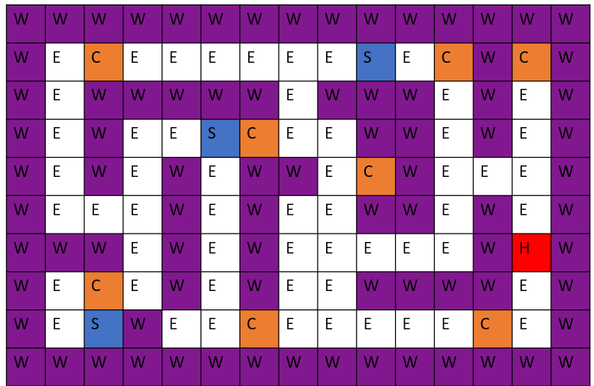

Implementation
  - This Maze can be described using strings for each row as follows:

“W, W, W, W, W, W, W, W, W, W, W, W, W, W, W”
“W, E, C, E, E, E, E, E, E, S, E, C, W, C, W”
“W, E, W, W, W, W, W, E, W, W, W, E, W, E, W”
“W, E, W, E, E, S, C, E, E, W, W, E, W, E, W”
“W, E, W, E, W, E, W, W, E, C, W, E, E, E, W”
“W, E, E, E, W, E, W, E, E, W, W, E, W, E, W”
“W, W, W, E, W, E, W, E, E, E, E, E, W, H, W”
“W, E, C, E, W, E, W, E, E, W, W, W, W, E, W”
“W, E, S, W, E, E, C, E, E, E, E, E, C, E, W”
“W, W, W, W, W, W, W, W, W, W, W, W, W, W, W”

Where:
W= Wall
C = Clue x8 – The Clue set must have a minimum of 8 clues
S = Spy x3 (Must be a different character than Empty)
H = Hero x1
E = Empty

  - Currently, I am using colours (Ref: MS colour picker¹⁴) for the elements of the Maze as follows because I drew my prototype design on PowerPoint, using PowerPoint colours that I thought provided a good contrast and provided the retro feel my stakeholders are wanting:

Element | Hex colour
Wall | #821890
Empty | #FFFFFF
Clue | #ED7D31
Hero | #FF0000
Spy | #4472C4

  - I have created a text file and named it Maze1.txt because this filename is already in my database. This will be used as test data for my maze.
Why? I have created a grid that is 10 x 15 because this feels like a reasonable size for an admin to type up and it produces a range of different situations for my characters to test, including dead ends and bottlenecks.

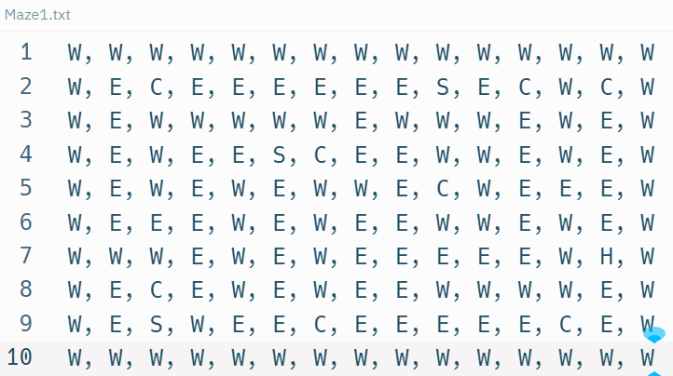

  - The Maze needs to be associated with a Clue Set that contains a sufficient number of clues for the gameplay in the Maze. Again, I can use a textfile and the string parts can easily be displayed on the screen. The elements of the Clue Set are as follows:
- A Clue – a question asked to the User that requires an answer to be entered.
- Correct answer – to compare the User’s input to.
- Difficulty Level – an integer level to represent Easy, Medium or Hard for an algorithm to select from.
- MaxTime – a time field for how long to give to respond to a Clue – Future Development Idea: in future, it might be desirable to add a MaxTime for solving each clue.
Design
  - Here are my development Clues for a Clue Set:
Why? I have created this test Clue Set to provide me with some easy clues that I can use during development. I expect that I will need to answer these clues frequently during game development, so I wanted some answers that were short and easy to type in. There are a few longer answers and also some numerical answers in my test Clue Set to see how my programme would react to the different answers:

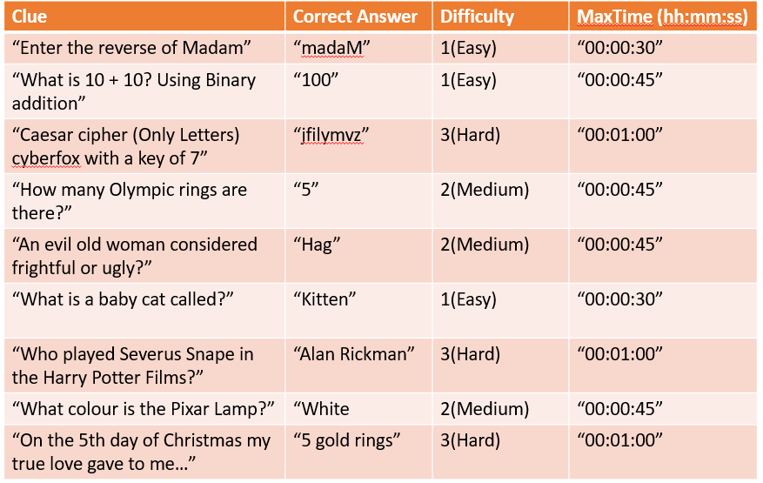

Implementation
  - I have created the Clue Set “Cyber.txt” which contains my development clues as follows:

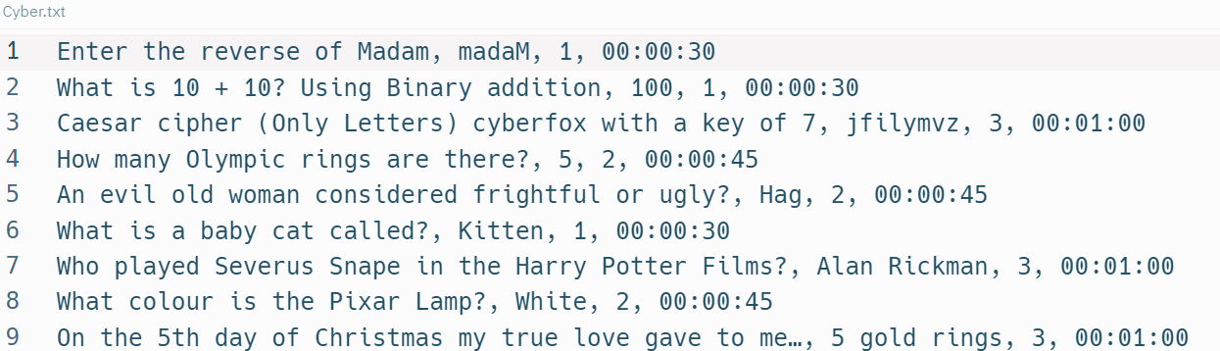

  - The next part of the process is associating the Clue Set with the Maze and for this, I did the following:

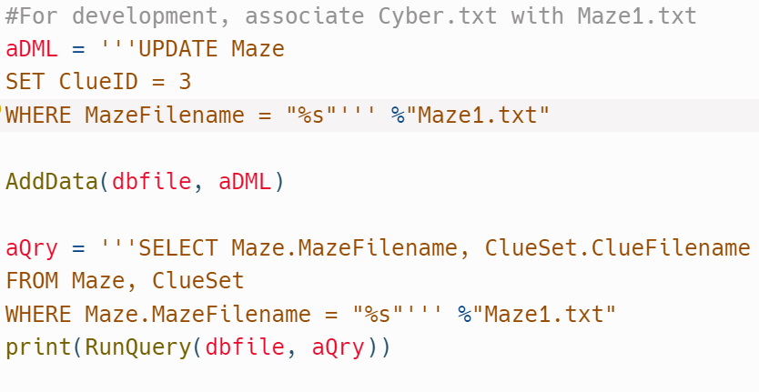
I have tried to update the maze table (Ref: https://www.sqlitetutorial.net/sqlite-update/¹⁵)
to associate Maze1.txt with Clue Set Cyber.txt
I ran this Query to check the association has worked.

  - But, the results of my Query were not what I expected:

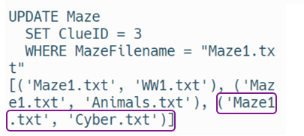
The operations have worked without errors.
BUT the answer table from the query shows 3 results when there should only be 1. The 3 results include the correct result, but I have 2 extras

  - I investigated the problem as follows:
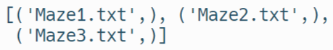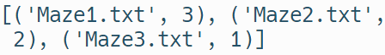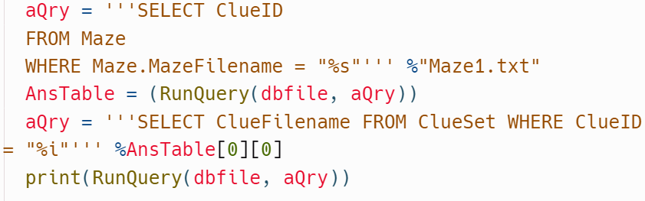
Querying the MazeFilenames in the Maze table shows there are only 3 distinct filenames – no multiples of the same Maze file. This is OK.
Each Maze is only associated with one Clue Set. This is OK.
The answer was to run 2 queries:
1 to find the ClueID in the Maze table.
1 to find the corresponding filename in the Clue Set table.
  - Now I know that I need to run 2 queries, I ran the following to show that the Clue Set and Maze was associating correctly:

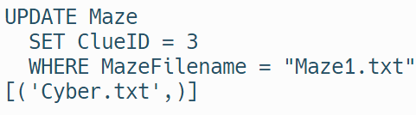
The Clue Set and Maze are now associating correctly to provide the right result.

Design
  - I am now going to continue to consider the different elements of my decomposed system to create a design for my game screen in its entirety for later implementation within the coloured box on the diagram below:

  - As part of the design, I considered the layout of the variables around the game. The current score, time elapsed/time remaining, and the amount of lives left to the user all need to be displayed on screen as well as the maze. Why? These extra elements should be displayed as well as the maze so that the user can track their progress and react appropriately as they play the game. This is my first iteration of the game layout:

Score:
Lives:
Time Taken:
Game Stats as it is played updated in real time
Cyber Maze
Name of Maze selected
The Maze game itself
The NumRows and NumCols affects the size of the game window

